COVID-19-Impact and Need of a Post Pandemic Crowd Safety:

**A Review**

1Pranav Taneja,

Bachelor of Technology, Department of Computer Science and Engineering, Panipat Institute of engineering and technology, Samlkha-132101, Haryana, [pranav.taneja36@gmail.com](mailto:pranav.taneja36@gmail.com)

2Manan Arora,

Bachelor of Technology, Department of Computer Science and Engineering, Panipat Institute of engineering and technology, Samlkha-132101, Haryana,[mananarora200@gmail.com](mailto:mananarora200@gmail.com)

3Abhay Mendiratta,

Bachelor of Technology, Department of Computer Science and Engineering, Panipat Institute of engineering and technology, Samlkha-132101, Haryana,[mabhay1994@gmail.com](mailto:mabhay1994@gmail.com)

4Alankrita Aggarwal,

Assistant Professor, Department of Computer Science and Engineering, Panipat Institute of engineering and technology, Samlkha-132101, Haryana,alankrita.agg@gmail.com

**Abstract**

The world is going through one of the worst pandemics ever seen. After concurrent lock-downs as the government is easing out, more and more people are heading towards the streets and are on the verge of risking their lives there.This leads to a need of such a system that not only provides a user with relevant updates regarding this disease but is essentially a useful tool that can be used to provide a safest path between a source and a destination. Most of the people now are equipped with some kind smart devices, be it some kind of smartphone or personal computer or a watch wrapped around your hand. Since the spread is nowhere near its termination and the world is having a lot of breakdowns be it in form of economic disruption or sociological imbalance due to this. Though the government is already working their hard on detecting and declaring hotspot zones there is no real time evaluation of potentially crowded zones that can be a source of disease synthesis too. There is a need of a system that can notify its users regarding any kind of potentially harmful zones and since getting on road is more than a necessity now a safe route provisioning system is also a dire need of situation in order to stop the spread.

**Keywords:** *Covid-19, Pandemic, Hotspot Zones, Corona Zones, Crowded Areas*

**1. Introduction: Impact of COVID-19 in India**

Our world has been facing a major humanitarian crisis since World War II. Many countries are most affected by COVID-19. To date, more than 6.2 million people have come in contact with COVID-19 and greater than 0.38 million people have are dead worldwide. Also, billions of people are concerned about the devastating effects of the global epidemic of COVID-19 (R. Lovreglio et al, 2019)

**2. Health Issues**

The Coronavirus epidemic has bloomed to 197 countries, with more than 2.5 million confirmed cases and more than 151,000 deaths worldwide since April 20. Leading health workers prone to huge risk of contamination and death.

Leading health professionals are at the verge of risk for psychological and physiological aftermaths due to the treatment of infected people with Corona Virus. After various researches, preliminary information approves early methodologies for reducing the inspection of infection, temporary change and aid measures could reduce death rate. (Shaukat, Ali & Razzak, 2020).

**3. Economic Disrupt**

Foreign and foreign tourism is banned, and tourism and tourism revenues, accounting for 9.2% of GDP, will weigh heavily on GDP growth rates. Flight costs will fall by USD 1.57 billion. Oil also took a downgrade in price in March (Chaudhary, Sodani & Das, 2020). Though decrease in oil price will reduce economic deficits, cash will increase. Money continues to plummet. MSMEs will incur significant costs. The crisis has seen a mass exodus of people from other parts of the world. Their main concerns were job losses, daily assignments.

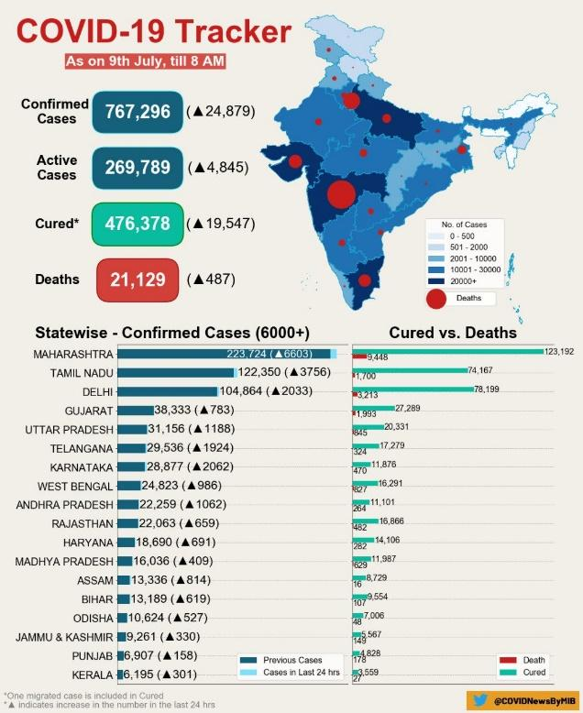

**Figure1:https://twitter.com/covidnewsbymib/status/1268042538755198976**

**4. Situation of Poverty**

In the absence of solid data on the impact of this ongoing crisis, the only window we have to understand the situation of workers in Indian cities is anecdotal. However, large-scale telephone research is one way to measure ground reality.

But representative, reliable and reliable telephone research is also challenging in popular times in India where poor people have limited access to calls and/or change phone numbers regularly. The existing respondent database can deal with some of the problems associated with telephone survey representation.

Figure 2 shows the countries where poverty can increase dramatically. It is far from the biggest effect that can be seen in the Country. India is guilty of having a large number of high-risk people, who have just escaped poverty, along with the most important collapse expected in economic growth. India has seen an upscale of growth of 11% in 2020, which is one of the deepest economies in the world. This has dramatically changed the course of poverty. India has recently relinquished its title as the country with the highest poverty rate in Nigeria.

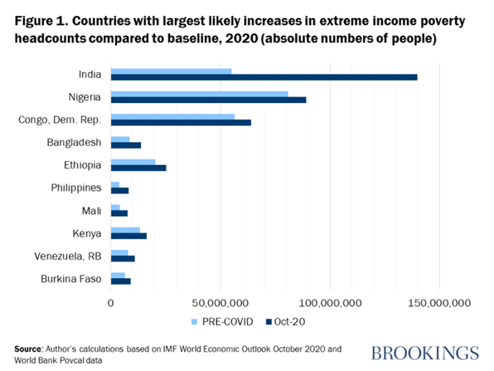

**Figure2:** **https://www.brookings.edu/blog/future-development/2020/10/21/the-impact-of-covid-19-on-global-extreme-poverty/**

Corona Virus is hugely regarded as a non-permanent threat to the economy. In many countries, however, economic damage can last a long time, and this is a real danger to families drawn into poverty. The situation of poverty for little time is difficult, but some people have their methodologies to deal with it. But in the long run, poverty has its great impact- starvation, exposure to infection, illiteracy. So, it is helpful to consider the long-term impact as well, despite all warnings related to any extreme economic forecasts (Kharas, 2021).

**5. Impact on Social and Mental Health**

The Corona 2019 virus (COVID-19) may not kill children and adolescents as adults, but it does cause great stress youngsters.

Youngsters face severe and ongoing mental panic as a result of family issues, hampering of routine life, increment in domestic violence, and limited access to friends. During an epidemic, young people at verge of mental health hampering can aided by happy peer life and morale boost for teachers. It is high time to be informed about psychological health of young people in India systematically (Burn & Mudholkar, 2021).

**6. Education System**

The shocking impact of COVID-19 has seen the daylight with its context. Also, a large part of the international government quickly shut down educational institutions trying to cover the Corona Virus epidemic. In India, the provincial government, as part of a national ban, has closed all educational institutions, and as a result, students from kindergarten to college students are affected. It has provided us with an e-learning program.

Many companies have tried to take advantage of this event by offering free online courses or restrictions on participating in e-courses. These methods were met with a surprising effect from youngsters where some new companies were witnessing excessively as a 26% increase in studying. Long-term study seems to be the perfect answer for college students, travel, and affordable admission to classes. E-learning adds a lot of interest and attention such as comparisons and teaching to the classroom ("COVID-19 and its impact on the System - India Legal", 2021).

**7. Causes of spread of Virus**

When somebody is infected with COVID-19 he/she develops anxiety or coughs, they produce small droplets of infected mucus. These droplets travel into the exteriors of an infected person, thus causing contamination. There are other reasons for the spread of the virus.

**7.1 Travelling and Social Gatherings**

Religious travelling is a huge source of income for many countries. All the important religious sites attract many visitors from all over the world. Religious tourism has been in operation for months and has led to mass mobilization (MRGs) which poses a serious threat to public health. It is always a challenge for higher authorities to make effective protection methodologies (Mubarak & Zin, 2020).

**7.2 Poor Health Facilities**

India's health care provisioning is poor in delivering Corona Virus transfers, particularly the most populous countries of northern India due to a decrease in number of doctors and other hospital amenities. The Corona Virus epidemic presents unique opponent due to the improper diagnostic methods, a monitoring system that is not well, and moreover lack of health care (Kumar, Rajasekharan Nayar & Koya, 2020).

**7.3 Mentality of Society**

Many are breaking lock-downs across country which increases the risk of coronary transmission. Therefore, the nation is at verge of entering a social upheaval. While most people follow the rules of the lock and follow the eviction of the community, some are breaking the regulations daily, by going to temples and gatherings. Articles are published about misconduct by veterans, health workers, and the police. This could undermine the world's self-sacrificing spirit and help to reduce the spread.

**8. Analysis of total number of positives cases, deaths & recovered cases in India**

Department of Health wrote on Twitter that India's recovery rate Corona Virus is one of the greatest throughout. At about 96 percent, India's recovery is higher global rate of 71 percent and more than that of other countries.

India announced 24,000 new cases of Corona Virus deaths and 360 deaths on Friday accounting for a debt of about 1 million diseases and 150,000 deaths worldwide. Now number of active cases in the country is 300,000 patients, making up for 3.3 percent of the all cases ("Covid-19 retrieval rate in India among the largest in the world: Department of Health - ET HealthWorld", 2021).

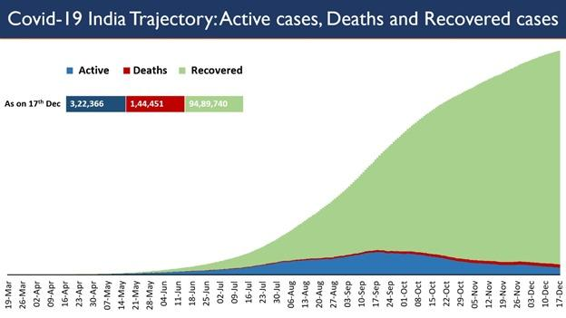

**Figure3: https://twitter.com/mohfw_india/status/1340122207985389569**

**9. India fighting with Corona Virus**

Various strategies have been taken into consideration for this. We have accomplished in slowing down the curve while other powerful nations still face it. India currently has a lower number of deaths compared to others.

The Indian (central) government is trying hard to reduce the spread continuously, medical organization, nurses, NGOs, police, and politics are taken aid of. The united efforts of all key personnel, importantly hospital staff and other workers and the continuous and obedient support of the Indian people have been a major aid for the eroding this epidemic from its roots. The Indian government became heavily involved in the outbreak of COVID-19 and began scanning everyone (Ghosh, Nundy & Mallick, 2020).

**10. Current Scenario**

No one ever thought about how this world would happen before March. Our whole life has been disrupted. Everyone is concerned about physical and emotional life, employment, money, and health.

**10.1 Financial Reconstruction**

During the economic recovery, emphasis is on remote association, flexibility, AI, and robots. Brent Crude charges $ 26.3 last week, preventing the oil economy from sinking into businesses that create rapid fatigue. The digital economy will prosper. Features such as home entertainment, home improvement, home schooling, homework will greatly improve. Over-the-tops will grow significantly which will transport Telcos to Telco-Over-the-top’s. Remote Association will also contribute to rising commodity prices over the past few decades. People who can live in small cities and work in organizations based in IT Industries will curb the burden from big cities. (Alankrita et all, 2020).

**10.2 Health and Research**

Now people will lay more emphasis on protection and healthcare amenities. Moreover, people will now make more expenditure in these fields. More health facilities will be developed, instruments of medical aid will aid in major hospital features. Now there will be more investment in virology and methods to study in this field. Countries like Russia have made and tried to test the 'Sputnik-V' vaccine (Talha Khan Burki 2020).Our pharmaceutical companies are working continuously to find the vaccine for this virus. In the future, dealing with large amounts of data will require data analysis techniques such as machine learning, integration, and big data analysis.

**10.3 Austerity**

Significant reductions in ticket size are expected soon. People are more likely to buy cheap goods that fit their need for costlier alternatives. People can make better decisions than they do.

**10.4 Environment**

The people after pandemic will look more focused on the weather and nature. This disease has obligated us to consider the consequences of pollution. The winner will be natural. The epidemic will slow down the urban economy and reduce traffic congestion. They do not believe in the natural world as a whole. People will prefer digital meetings over travel and will reduce road loads and reduce land pollution. The sky will be brighter and the air will be easier to breathe.

**10.5 Study on Transportation**

**A large amount of data has been collected by various Map systems such as Baidu Maps , which is a widely used mapping system in china to study the detailed pattern of transportation in pandemic. A data dfriven analysis has also been conducted to gain knowledge about** 1) means of transportation, 2) type of visited venues, 3) check-in time of venues, 4) preference on "origin-destination'' distance, and 5) "origin-transportation-destination'' patterns.(Jizhou et al, 2020)

**11. Effective Techniques of Transportation based on User preferences**

Majority of Navigation devices now have a user profile based system so that each navigation route can be corresponded to a each user's personae. For reference the business profile might be different from a user's personal profile such as its personal profile may have routes for destinations like food courts etc. Similarly for our case in a Doctor’s scenario a personal profile would be different from a work profile and hence would lead to a specific route provisioning system. In addition, blockages may also be established using the device to avoid selected areas, e.g., hotspot zone areas, high crime rate areas, in the navigated route, or to block transmission of selected information concerning, e.g., uninteresting facilities and events, to the navigation device. (Obradovich et al, 2003)

**12. Conclusion & Future Scope**

Considering the current scenario we are developing such a system that not only functions as a notifying system that provides relevant information about COVID -19 but most importantly can be used as a Safety Enhancement Tool that helps its users to travel safely in between two locations by providing a path that is least affected by a declared hotspot zone, moreover it can also inform them about any potential crowded zones which can be a source of spread too.

The system operates on the principle of data collection for users by downloading their current location which provides a source of information for sharing and counting congestion in that region.

For example: Many doctors have to reach Hospital from their homes so they can just provide the source as home and destination as hospital and the system will determine the safest path between these two points excluding hospital and home, as they are the provided source and destination from the user and the user has to ultimately reach there.

Hence raise awareness of areas where the crowd is large and potentially dangerous to travel so it ensures public safety in general.

**12. Acknowledgment**

I would like to thank and acknowledge, Panipat Institute of engineering and technology, Samlkha-132101, Haryana (India) for providing me the resources and help in carrying out the research work.

**References**

1. Shaukat, N., Ali, D., & Razzak, J. (2020). Physical and mental health impacts of COVID-19 on healthcare workers: a scoping review. *International Journal Of Emergency Medicine*, *13*(1). doi: 10.1186/s12245-020-00299-5
2. Chaudhary, M., Sodani, P., & Das, S. (2020). Effect of COVID-19 on Economy in India: Some Reflections for Policy and Programme. *Journal Of Health Management*, *22*(2), 169-180. doi: 10.1177/0972063420935541
3. Kharas, H. (2021). The impact of COVID-19 on global extreme poverty. Retrieved 10 January 2021, from <https://www.brookings.edu/blog/future-development/2020/10/21/the-impact-of-covid-19-on-global-extreme-poverty/>
4. Burn, W., & Mudholkar, S. (2020). Impact of COVID-19 on mental health: Update from the United Kingdom. *Indian Journal Of Psychiatry*, *62*(9), 365. doi: 10.4103/psychiatry.indianjpsychiatry_937_20
5. COVID-19 and its Impact on Education System in India - India Legal. (2021). Retrieved 10 January 2021, from <https://www.indialegallive.com/legal/covid-19-and-its-impact-on-education-system-in-india/>
6. Mubarak, N., & Zin, C. (2020). Religious tourism and mass religious gatherings — The potential link in the spread of COVID-19. Current perspective and future implications. *Travel Medicine And Infectious Disease*, *36*, 101786. doi: 10.1016/j.tmaid.2020.101786
7. Kumar, A., Rajasekharan Nayar, K., & Koya, S. (2020). COVID-19: Challenges and its consequences for rural health care in India. *Public Health In Practice*, *1*, 100009. doi: 10.1016/j.puhip.2020.100009
8. Covid-19 recovery rate in India among highest in the world: Health Ministry - ET HealthWorld. (2021). Retrieved 10 January 2021, from <https://health.economictimes.indiatimes.com/news/industry/covid-19-recovery-rate-in-india-among-highest-in-the-world-health-ministry/79779406>
9. Ghosh, A., Nundy, S., & Mallick, T. (2020). How India is dealing with COVID-19 pandemic. *Sensors International*, *1*, 100021. doi: 10.1016/j.sintl.2020.100021
10. Alankrita Aggarwal (0000-0002-0931-1118). (2021). Retrieved 10 January 2021, from <https://orcid.org/0000-0002-0931-1118>
11. R. Lovreglio, E. Ronchi, and M. J. Kinsey. "An Online Survey of Pedestrian Evacuation Model Usage and Users," Fire Technology, November 2019, DOI: 10.1007/s10694-019-00923-8.
12. I. T. Yu et al. "Evidence of airborne transmission of the severe acute respiratory syndrome virus," New England Journal of Medicine, Vol. 350, No. 17, pp. 1731–1739, 2004.
13. D. Lewis. "Is the coronavirus airborne? Experts can’t agree," Nature, Vol. 580, No. 7802, pp. 175–175, April 2020, DOI: 10.1038/d41586-020-00974-w.
14. World Health Organization. COVID-19: physical distancing; 2020. Available from: https://www.who.int/ westernpacific/emergencies/covid-19/information/physical-distancing.
15. Tian H, Liu Y, Li Y, Wu CH, Chen B, Kraemer MUG, et al. An investigation of transmission control measures during the first 50 days of the COVID-19 epidemic in China. Science. 2020; 368(6491):638. https://doi.org/10.1126/science.abb6105 PMID: 32234804
16. Rader B, Scarpino S, Nande A, Hill A, Reiner R, Pigott D, et al. Crowding and the epidemic intensity of COVID-19 transmission. medRxiv. 2020. <https://doi.org/10.1101/2020.04.15.20064980>
17. Adrian, J., Bode, N., Amos, M., Baratchi, M., Beermann, M., Boltes, M., Corbetta, A., Dezecache, G., Drury, J., Fu, Z., Geraerts, R., Gwynne, S., Hofinger, G., Hunt, A., Kanters, T., Kneidl, A., Konya, K., Köster, G., Küpper, M., … Wijermans, N. (2019). A Glossary for Research on Human Crowd Dynamics. Collective Dynamics, 4. <https://doi.org/10.17815/CD.2019.19>
18. Anderson, R. M., Heesterbeek, H., Klinkenberg, D., & Hollingsworth, T. D. (2020). How will country-based mitigation measures influence the course of the COVID-19 epidemic? The Lancet, 395(10228), 931–934. <https://doi.org/10.1016/S0140-6736(20)30567-5>
19. Bonell, C., Michie, S., Reicher, S., West, R., Bear, L., Yardley, L., Curtis, V., Amlôt, R., Rubin, G.J., 2020. Harnessing behavioural science in public health campaigns to maintain ‘social distancing in response to the COVID-19 pandemic: key principles. J Epidemiol Community Health.s
20. Mohler, G., Bertozzi, A. L., Carter, J., Short, M. B., Sledge, D., Tita, G. E., ... & Brantingham, P. J. (2020) Impact of social distancing during COVID-19 pandemic on crime in Indianapolis.
21. Mittal, M., Sharma, R. K., & Singh, V. P. (2015). Modified single pass clustering with variable threshold approach. International Journal of Innovative Computing Information and Control, 11(1), 375-386.
22. Mittal, M., Sharma, R. K., & Singh, V. P. (2014). Validation of k-means and threshold based clustering method. International Journal of Advancements in Technology, 5(2), 153-160.
23. Obradovich, (2003) Technique For Effective Navigation Based On User Preferences. (2003). Patent No.: US 6,542,812 B1
24. Huang, J., Wang, H., Fan, M., & Zhuo, A. (2021). Understanding the Impact of the COVID-19 Pandemic on Transportation-related Behaviors with Human Mobility Data | Proceedings of the 26th ACM SIGKDD International Conference on Knowledge Discovery & Data Mining. Retrieved 8 February 2021, from https://dl.acm.org/doi/abs/10.1145/3394486.3412856